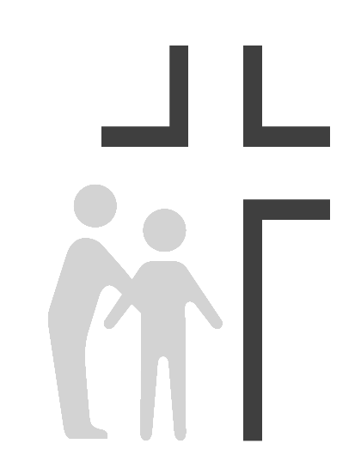
Good Samaritan Health Center of Cobb
Job Description
Dental Hygienist

Effective Date: | 08/01/2008 | Reports To: | Dental Director
Review Date: | 02/11/2014
SUMMARY OF DUTIES: Responsible for providing professional dental hygiene care to clinic patients under supervision of dental staff.

SUPERVISION EXERCISED: Volunteers, as needed.

SUPERVISION RECEIVED: Reports to the Dental Director, also takes direction from COO.
PRINCIPLE RESPONSIBILITIES:
- Can fulfill the clinic’s mission to spread the love of Christ through quality healthcare to those in need while providing appropriate physical, emotional, and spiritual care for the whole person.
- Assesses patient's general condition and takes appropriate vital signs.
- Assists dentists with examinations, diagnostic procedures and treatments.
- Provides dental hygiene care to patients including prophy, scale, curettage, root planning, polish, fluoride treatments, take study models/identification models as needed, expose, develop, and mount X-rays.
- Ensures appointment preferences are given to patients in emergency situations.
- Fulfills patient documentation responsibilities which may include: reviewing medical history and updating in the chart, charting findings from an oral cancer exam, charting dental conditions including decay, restorations, and missing teeth, charting gingival conditions including bleeding, recession, and missing teeth, checking schedules and organizing patient flow. Relays all findings to the Dentist and the patient.
- Documents all activities/interventions, patient/family responses, medication dispensed/prescribed, etc., in the medical record, sends and obtains patient medical/dental records if needed.
- Promotes wellness by providing patient education materials and communicating dentist’s advice / instructions. Educates patient on brushing tongue and teeth, flossing, rinsing, gum disease, and nutrition.
- Fulfills environmental responsibilities as assigned which may include: setting up instruments and equipment according to clinic protocol, cleaning exam/procedure rooms and instruments between patient visits to maintain infection control, cleaning sterilizer according to scheduled maintenance program, ordering, sorting and storing supplies to restock exam/procedure rooms, changing x-ray processor solutions on schedule, sharpening instruments, reporting any repairs that are needed.
- Adheres to infection control, safety protocols per OSHA guidelines, and confidentiality policies per HIPAA guidelines.
The job holder must demonstrate current competencies applicable to job position.

OSHA ADVISOR RESPONSIBILITIES:
- Act in an advisory capacity to educate medical and dental in the effectiveness of proper procedure to prevent transmission of infection among patients and health care providers.
- Organize and maintain OSHA manual.
- Organize and maintain MSDS manual.
- Organize annual Blood Borne Pathogen Transmission Update meeting for all staff.
- Conduct regular OSHA audit and safety inspection checklist once a month.
EDUCATION: Graduate of an accredited RDH program.
EXPERIENCE: Minimum 2-3 years RDH experience, clinical experience preferred.

KNOWLEDGE:

- Knowledge of professional dental hygiene regulations and practices to give and evaluate patient care
- Knowledge of policies and procedures related to infection control, environmental safety and patient confidentiality.
- Knowledge of dental chart reporting/records.

ABILITIES:

- Ability to work effectively as team member with dentists and other staff, communicating clearly and effectively.
- Ability to plan, prioritize, and complete delegated tasks.
- Ability to appropriately interact with patients, families, staff, and others.
- Ability to flexibly respond to changing demands, and react calmly and effectively in emergency situations.
- Ability to demonstrate compassion and caring in dealing with others in a way that supports the Center’s mission to spread the love of Christ through quality healthcare to those in need.

ENVIRONMENTAL WORKING CONDITIONS

- Combination of exam rooms and dental offices. Frequent exposure to communicable diseases, toxic substances, ionizing radiation, medicinal preparations and other conditions common to a clinical environment.
- This position is classified as a category 1 position under the OSHA guidelines with high risk of exposure to blood-borne pathogens and other potentially infectious materials.

PHYSICAL & MENTAL DEMAND: Must be able to exert up to 40 pounds of force occasionally to lift 40 pounds. Requires standing and walking for extensive periods of time. Requires corrected vision and hearing to normal range. Requires working under stress in emergency situations and occasional irregular hours.
- Standing: 30% of the workday
- Sitting: 40% of the workday
- Walking: 20% of the workday
- Lifting: 10% of the workday

This description is intended to provide only basic guidelines for meeting job requirements. Responsibilities, knowledge, skills, abilities, and working conditions may change as needs evolve.

