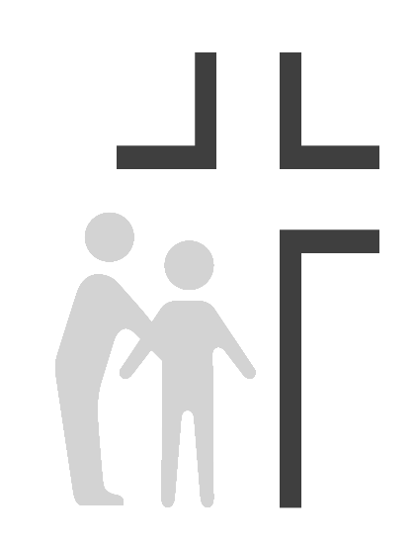
Good Samaritan Health Center of Cobb
Physician Job Description

Effective Date: | April, 2016 | Reports To: | Medical Director
Review Date:
Summary of Duties: The Staff Physician for the Center functions primarily as a staff physician with administrative duties assigned by the Medical Director. Licensed Physician will provide professional medical care to individuals from various cultures and ethnic backgrounds. Must be compassionate, sensitive, understanding, and support the Center’s Ministry to provide quality care to those in need. Must have the ability to supervise others and work effectively as a team with other staff, dentists, and volunteers and donors.
Clinical SUPERVISION EXERCISED: Medical Clinic staff, Volunteer Physicians
sUPERVISION RECEIVED: Medical Director
Principal Responsibilities:
- Can fulfill the Center’s mission to spread the love of Christ through quality healthcare to those in need while providing appropriate physical, emotional, and spiritual care for the whole person.
- 80% of Providers’ efforts are focused on fulfilling the Center’s mission by providing appropriate physical, emotional, and spiritual care for the whole person.
- Responsible for focusing approximately 20% of their leadership efforts on the overall clinical operations of the organization including planning and evaluating programs that meet the community’s needs and maintaining compliance with the mission and board policies.
- Assist in overseeing function of the QI/QA Program by ensuring that the QI/QA plan is properly developed, implemented, and coordinated.
- Participates in the development of mechanisms for assuring accountability of the medical staff for the care provided and for assuring the provision of the same level of quality of patient care by all professionals.
- Ensure that current services are needed and utilized, to their fullest extent, by the Center’s clients.
- Assist in preparation of annual reports including budgetary, planning, and quality reporting, pertaining to the medical department, as may be required.
- Responsible for the team work and enforcement of the staff policies and procedures.
- Supports clinical education within the Center including staff and volunteers.
- Conduct patient care review for Quality Assurance purposes.
- Obtain an adequate medical history on each patient both scheduled and walk-in.
- Develop a comprehensive treatment plan based upon diagnostic radiographs, clinical examinations, and information gathered from medical and dental history.
- Perform professional medical work including primary and preventative care.
- Administers local anesthesia and performs post-operative treatment.
- Diagnose and treat diseases with the aid of biopsy and laboratory tests.
- Supports training for auxiliary medical personnel including volunteers.
- Oversees the instruction of patients and community on the importance of preventative medicine.
- Attends meetings and makes reports as required.
- Meets all guidelines for continuing medical education.
- Meets all HIPAA guidelines and regulations treating patient’s information with privacy and respect.
- Leads devotions with other employees on a rotating basis.
- Develop and oversee the treatment plans and communicates those plans to supplemental volunteer providers for implementation with patients.
- Serves as lead clinician as we seek a replacement for our current Electronic Medical Record.
The job holder must demonstrate current competencies applicable to job position.
Education: Family Practice or Internal Medicine graduate of an accredited medical program. Current licensure to practice Medicine in the State of Georgia.
EXPERIENCE: Five years of primary care medicine in private practice or community health center setting or comparable.
KNOWLEDGE:
- Knowledge of professional medical theory, practices, and regulations needed to provide and evaluate patient care.
- Knowledge of common safety hazards and precautions in order to establish/maintain a safe work environment.
- Knowledge of managing personnel in a compassionate yet effective and efficient way.
- Experience in dealing with patients of ethnically diverse backgrounds.
- Knowledge of Spanish is highly desirable although not required.

ABILITIES:

- Ability to maintain quality control standards.
- Ability to react calmly and effectively in emergency situations.
- Ability to interpret, adapt and apply guidelines and procedures.
- Ability to communicate clearly and establish/maintain effective working relationships with patients, medical staff and the public.
- Ability to type and utilize an Electronic Medical Record
- Ability to demonstrate compassion and caring in dealing with others in a way that supports the Center’s mission to spread the love of Christ through quality healthcare to those in need.
ENVIRONMENTAL WORKING CONDITIONS:
- Combination of exam rooms and medical offices. Frequent exposure to communicable diseases, toxic substances, ionizing radiation, medicinal preparations and other conditions common to a clinic environment.
- This position is classified as a Category 1 position under OSHA guidelines with high risk of exposure to blood-borne pathogens and other potentially infectious materials.
PHYSICAL/MENTAL DEMANDS: Requires standing and walking for extensive periods of time. Occasionally lifts and carries items weighing up to 10 pounds. Requires corrected vision and hearing to normal range. Requires working under stress in emergency situations and occasional irregular hours.

- Standing: 30% of the workday
- Sitting: 40% of the workday
- Walking: 20% of the workday
- Lifting: 10% of the workday

This description is intended to provide only basic guidelines for meeting job requirements. Responsibilities, knowledge, skills, abilities and working conditions may change as needs evolve.

