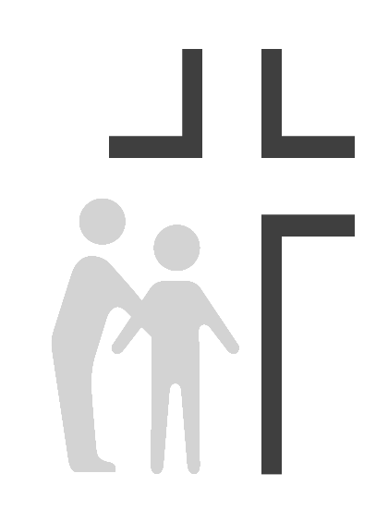
Good Samaritan Health Center of Cobb
Job Description
Family Physician

Effective Date: | 02/01/2020 | Reports To: | Medical Director
Updated: | 09/22/2021
SUMMARY OF DUTIES: Provide professional patient care as a Licensed Physician to individuals from various cultures and ethnic backgrounds. Must be compassionate, sensitive, understanding, and support the Good Samaritan Health Center’s Ministry to spread the love of Christ through providing quality healthcare to those in need. Must have the ability to supervise others and work effectively as a team with other physicians, staff, and volunteers.

SUPERVISION EXERCISED: MA/nursing staff

SUPERVISION RECEIVED: Reports to Medical Director
PRINCIPAL RESPONSIBILITIES:
- Can fulfill the clinic’s mission to spread the love of Christ through quality healthcare to those in need while providing appropriate physical, emotional, and spiritual care for the whole person.
- Provide continuous, comprehensive primary medical care to adult and pediatric patients, as delegated by medical director within scope of practice guidelines.
- Provides care consistent with the quality standards of the organization, participates in peer review activities, and works with administration to reduce risk and maintain patient safety.
- Participate in group evening and weekend on call schedule (phone call only). Adhere to departmental policies, procedures and objectives, ongoing quality improvement objectives and safety, environmental, and infection control standards.
- Collaborate with and direct behavioral health personnel in providing appropriate behavioral health care for patients.
- Review and respond appropriately to diagnostic testing ordered by volunteer physicians
- Others duties as assigned by the CEO and Medical Director.

The job holder must demonstrate current competencies applicable to job position.
EDUCATION:
- MD/DO degree from an accredited medical school.
- Current license to practice in Georgia or the ability to obtain a license prior to the start of employment.
- Board certification in Family Practice or Med/Peds with a desire to serve both adult and pediatric patients

EXPERIENCE: Minimum five years as a practicing physician preferred

KNOWLEDGE:

- Knowledge of professional medical theory, practices and regulations to give and evaluate patient care.
- Knowledge of common safety hazards and precautions to establish/maintain a safe work environment.
- Knowledge of managing personnel in a compassionate yet effective and efficient way.
- Experience in dealing with patients of ethnically diverse backgrounds.
- Bilingual Spanish/English preferred.

ABILITIES:

- Ability to maintain quality control standards.
- Ability to react calmly and effectively in emergency situations. Ability to interpret, adapt and apply guidelines and procedures.
- Ability to communicate clearly and establish/maintain effective working relation- ships with patients, medical staff and the public.
- Ability to utilize the electronic medical records and provide accurate and complete documentation in a timely manner
- Ability to demonstrate compassion and caring in dealing with others in a way that supports the Center’s mission to share the love of Christ through quality healthcare to those in need.

ENVIRONMENTAL / WORKING CONDITIONS: Combination of exam rooms and medical offices. Frequent exposure to communicable diseases, toxic substances, ionizing radiation, medicinal preparations and other conditions common to a clinic environment.
This position is classified as a Category 1 position under OSHA guidelines with high risk of exposure to blood-borne pathogens and other potentially infectious materials.

PHYSICAL / MENTAL DEMANDS Requires standing and walking for extensive periods of time. Occasionally lifts and carries items weighing up to 10 pounds. Requires corrected vision and hearing to normal range. Requires working under stress in emergency situations and occasional irregular hours.

- Standing: 30% of the workday
- Sitting: 40% of the workday
- Walking: 20% of the workday
- Lifting: 10% of the workday

This description is intended to provide only basic guidelines for meeting job requirements. Responsibilities, knowledge, skills, abilities and working conditions may change as needs evolve.

Acknowledgment

I have read and understand my job description, and I have discussed my job requirements and responsibilities with my supervisor.

Print Name

Employee Signature Date

Supervisor Name

Supervisor Signature Date

